EMBEDDED SYSTEM WITH IOT
EXPERIMENT NO. 1

IOT-BASED AUTOMATED STREET LIGHTING SYSTEM

Name: Raphael S. Nano

Course/Section: CPE162P / C1

Date of Performance: January 21-23, 2024
Date of Submission: January 24, 2024

Ma'am Cyrel Manlises
Instructor

DISCUSSION

In the modern generation of continuously developing technology, urban cities around the world are responding to innovative solutions in order to further the efficiency in the city structures and roads. One such technology involves the Internet of Things, wherein it revolutionized various aspects of urban life. An example of this is the IoT-based automatic street lighting systems, where by integrating light sensors, data analytics, and connectivity, street lighting networks are able to provide illumination in the roads for both pedestrians and drivers. With that said, an IoT-based automated street lighting system was developed with the use of LEDs for the lights, photoresistor as the light sensor, and ESP8266 for the IoT-based component.

For experiment1, the objectives are as follows:
1. To demonstrate how an IoT based Automated Street Lighting System works.
2. To be able apply what you have learned in logic circuits and switching theory, microprocessors, CPE160P, and CPE161P.
3. To be able to apply embedded system with IoT using Arduino kit
4. To be able to use ThingSpeak for the data collection and analysis.
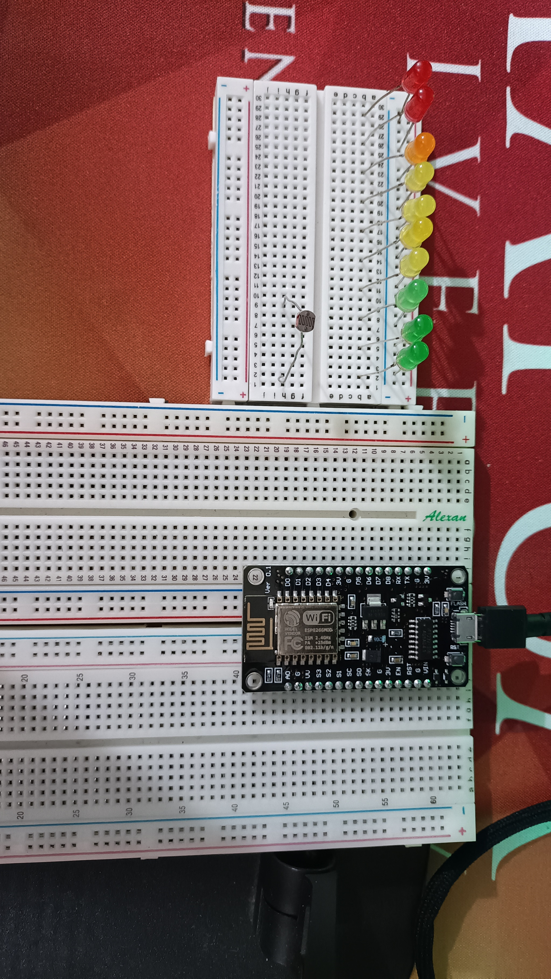
The materials involved in constructing the IoT-based automatic street lighting system are the ESP8266 WiFi module, LEDs, and photoresistor.

Figure 1. Major Components for the Experiment
For the external libraries, ESP8266WiFi.h and ThingSpeak.h are the only separate libraries included. Secrets.h is a file with definitions for ESP8266WiFi.h.
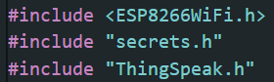

Figure 2. External Libraries Included

The primary aim of experiment 1 is to create an IoT-based automatic street lighting system, wherein it automatically switches the street light ON and OFF based on the amount of sunlight present. Additionally, Thingspeak will be used for the collection of the data and analysis.
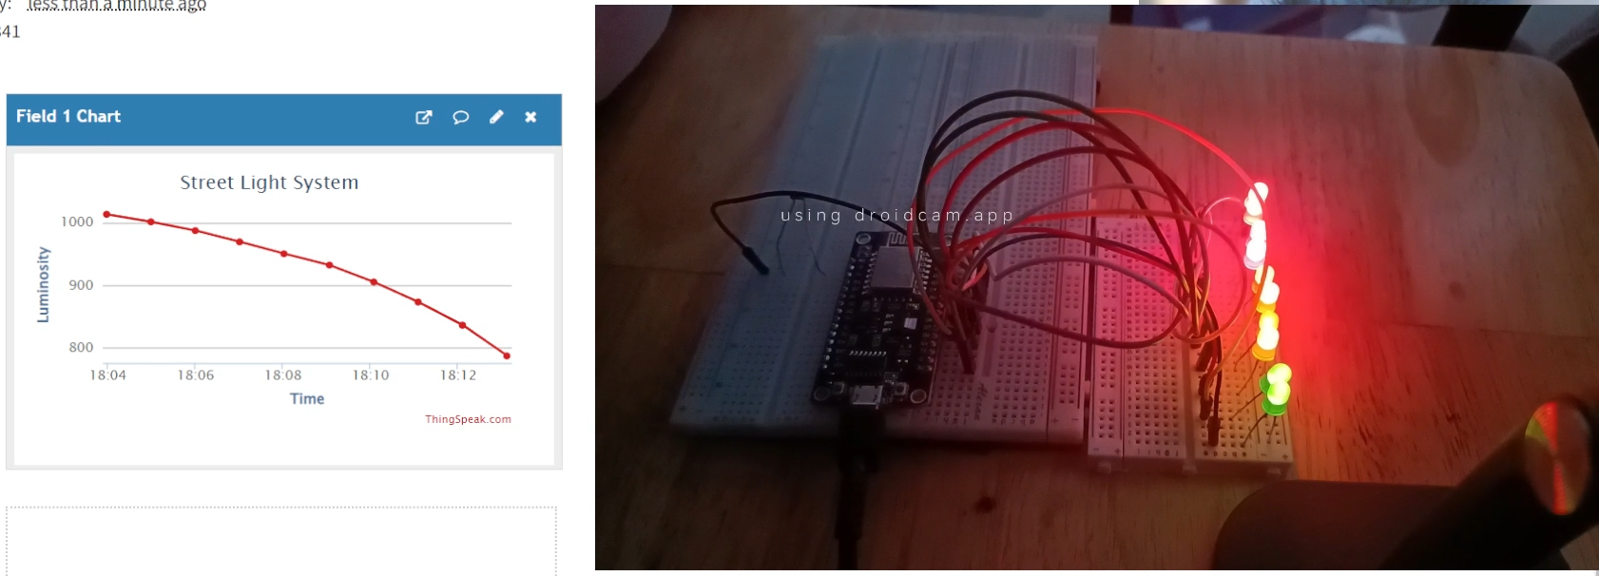

Figure 3. Final Output of the Experiment
The main components of this experiment are the photoresistor and LEDs. By simply using analogRead and digitalWrite, the LEDs are turned ON, depending on the light being received by the sensor. As seen in Figure 4, the ranges are as follows: 1st Level of Lack of Light: 0 - 700, 2nd Level: 650 - 750, 3rd Level: 750-850, 4th Level: 850-900, 5th Level: 900-1000, and 6th Level: Greater than 1000.
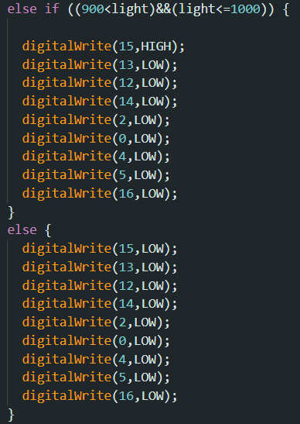
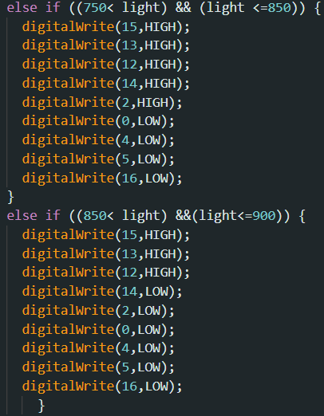
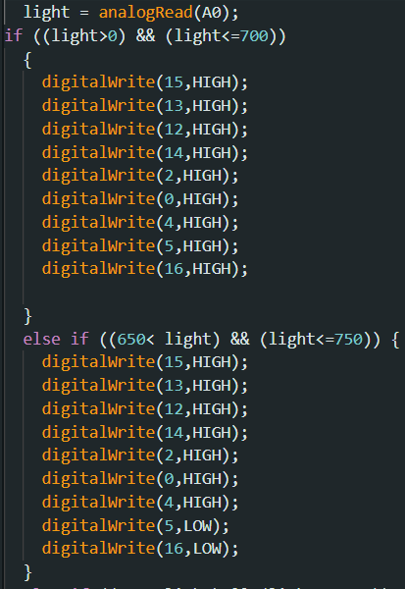

Figure 4. Street Lights Main Function

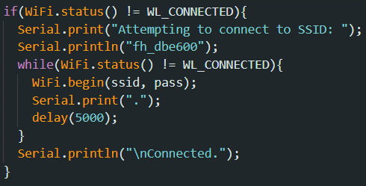
In order to connect the ESP8266 to Thingspeak, a WiFi connection should first be established. The code below tries to get connected to a particular network using Wi-Fi (fh_dbe600) and repeatedly attempts until an adequate connection is made. It delivers information to the person using it via the Serial Monitor, indicating the status of the connection attempt. After connecting to the WiFi, the Street Lights function will be activated.

Figure 5. WiFi Function

Afterwards, the luminosity value will be passed to the Thingspeak using the writeField function. A value was checked to see if the channel update is successful or not.
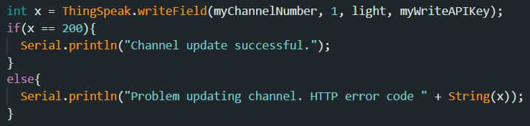

Figure 6. Thingspeak Function

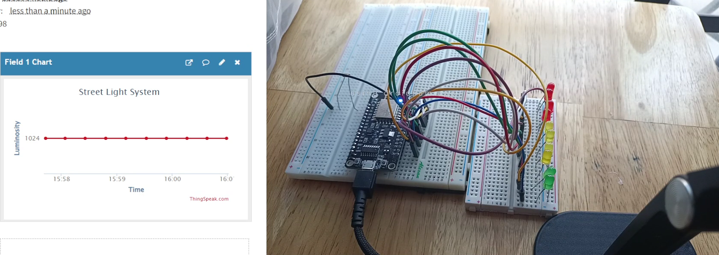
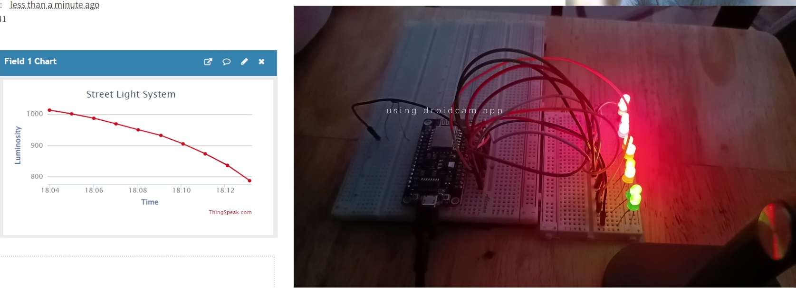
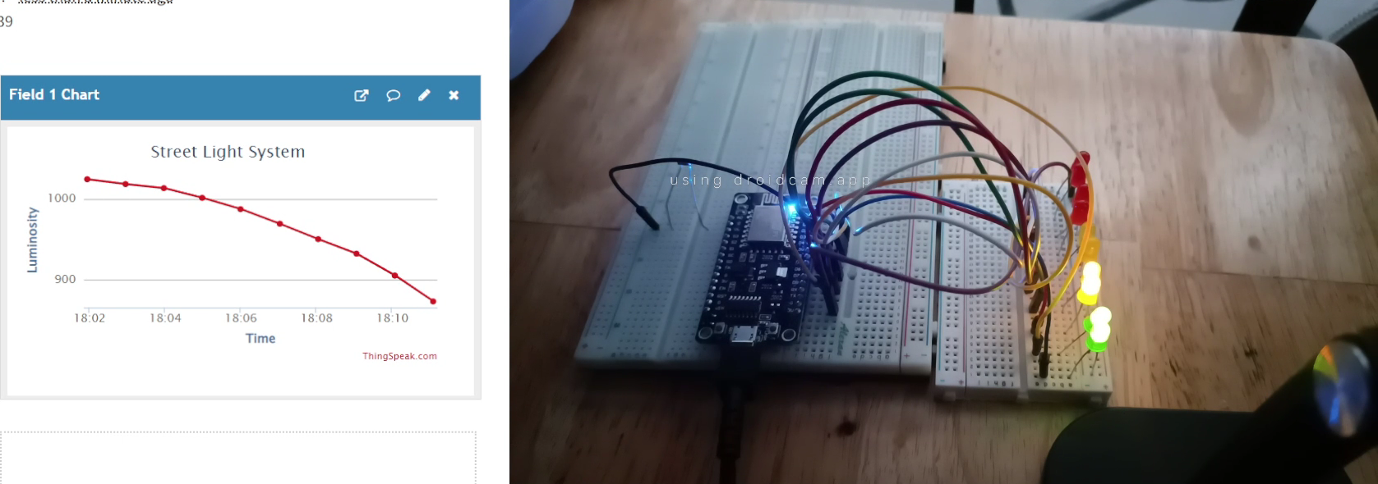
(7 PM)
(6 PM)
(10 AM to 5 PM)
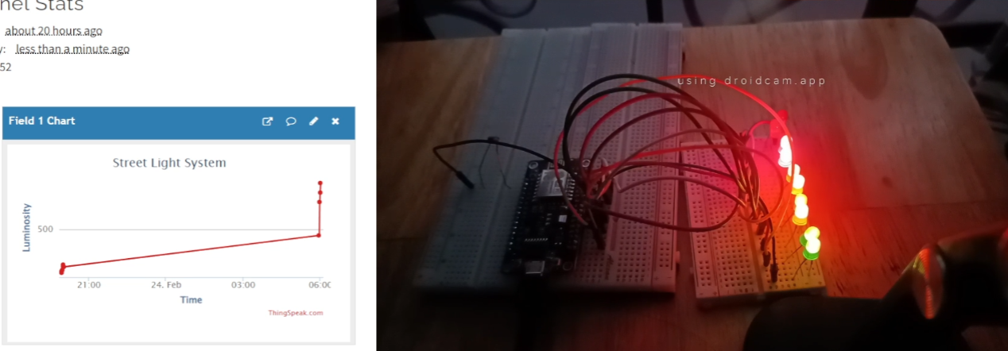
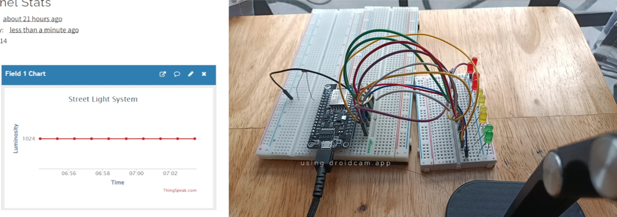
Figure 7. Final Outputs of Experiment 1
(7 AM)
(6 AM)
RESULTS
The IoT-based automated street lighting system heavily relies on the sunlight and the photoresistor that receives the light. As per the output of the LEDs, more LEDs are lit up as the sunlight gets dimmer. This means that the intensity of street lights is inversely proportional to the sunlight in the environment. The outputs for this experiment were recorded at these times: 6AM, 6:30AM, 10AM, 11AM, 4PM, 5PM, 6PM, 6:15PM, 7PM, and 8PM. The most LEDs turned ON are at times 6AM, 6:15PM, 7PM and 8PM onwards. The least LEDs turned ON are at times 10AM to 5PM. The gradual turning ON of the LEDs are evident in times 6:30 AM and 6:30 PM. This means that the sunrise is at 6-6:30 AM, and the sunset is at 6-6:30 PM.

CONCLUSION
In conclusion, the IoT-based Automated Street Lighting System works by using a conditional statement, wherein the outputs of the LEDs depend on the intensity of light being received by the photoresistor. More sunlight would mean less LEDs turned ON, and vice versa. The second objective was achieved by synchronizing the lighting up of LEDs, depending on the light received by the photoresistor, and by synchronizing the luminosity value in Thingspeak, demonstrating the usage of microprocessors, logic circuits, switching theory, CPE160P, and CPE161P lessons. The IoT portion was successfully integrated with the use of the communication and data writing between ESP8266 and Thingspeak, which was adequately performed as the graphs can prove the outputs of the luminosity. Hence, the IoT-based Automated Street Lighting System was successfully developed with its WiFi connection and the synchronization of outputs of the photoresistor and LEDs in Thingspeak.

